**TESTING DOCUMENT**

Software Testing:

* It is a part of software development process.
* It is used for checking errors and gaps in the software.
* The objective of testing is to release quality product to the client.

Software Quality:

* It helps to reduce problems and errors in the final product.
* It is defined as justification of all the requirements of a customer’s mind.

Quality software is reasonably

* Bug-free (it’s not possible to completely eliminate bugs from software)
* Delivered on time.
* Within budget.
* Meets requirements.
* Maintainable.

Product Vs Project:

* The software application is developed by the requirements of multiple customers is known as Product.
* The software application is developed by the requirement of specific customer is known as Project.

Why do we need testing?

* Identifying and fixing errors.
* It is cost effective, customer satisfaction, Product quality and security.
* Ensure that software is bug free.
* Ensure that system meets end user expectations.
* Fixing the bugs identified after release is more expensive.
* Error: A problem is created by human actions in the system is called Error.
* Defect/Bug: A mismatch between the expected and actual result of software development is called Defect/Bug.
* Failure: While using the system the deviation is identified by end-user is called Failure.

Why the software has bugs normally?

* Miscommunication or no communication
* Software complexity
* Programming errors
* Changing requirement
* Lack of skilled testers
* Human errors

Software Development Life Cycle (SDLC)

* SDLC is a process used by software industry to design, develop and test software’s.
* The life cycle includes five main stages.

1.Requirements Analysis

2.Design

3.Development

4.Testing

5.Maintenance

Waterfall Model (Advantages & Disadvantages)

* The Waterfall Methodology is also known as the Waterfall model.
* It is a sequential development process that flows like a waterfall through all phases of a project. (analysis, design, development, testing and maintenance)

Advantages of Waterfall Model

* Quality of the product will be good.
* Presence of a clear structure.
* Esay to manage.
* Here requirement changes are not allowed, and finding bugs will be less.
* Initial investment is less.

Disadvantages of Waterfall Model

* Requirement changes are not allowed.
* If there is any defect in requirement that will be continued in later phases.
* Testing will start after coding.
* Costly and inflexible.
* Total investment is more.

The goal of a software tester is to find bugs, find them as early as possible, and make sure they get fixed.

***Software bug* occurs when**

1. A bug can be caused by insufficient or incorrect design based on the specification.
2. Mostly, bugs arise from human errors in the source code of the software or product architecture.
3. Updates or changes in third-party libraries, APIs, or other external dependencies may introduce incompatibilities.
4. The number one cause of software bugs is the specification

Bugs are mainly caused by

* Specialization
* Design
* Code
* Others

**The bugs are caused for many reasons but main one is Specification.**

specifications are the largest bug producer it’s constantly changing, or it’s not communicated well to the entire development team. Planning software is vitally important. If it’s not done correctly, bugs will be created.

Software testing- It is process to test an application to find out error in it.

Checking the software is ok.

The goal of software tester to find bug.

Verifying and validating that a software or application is bug free.

**Testing Types:**

1. Manual Testing: Manual testing is a software testing method where a tester manually uses a software application to identify defects and issues.

Manual testing includes testing a software manually, i.e., without using any automated tool or any script.

1. Automation Testing: Automation testing, which is also known as Test Automation, is when the tester writes scripts and uses another software to test the product. This process involves automation of a manual process. Automation testing is used to re-run the scenarios that were performed manually, quickly, and repeatedly.

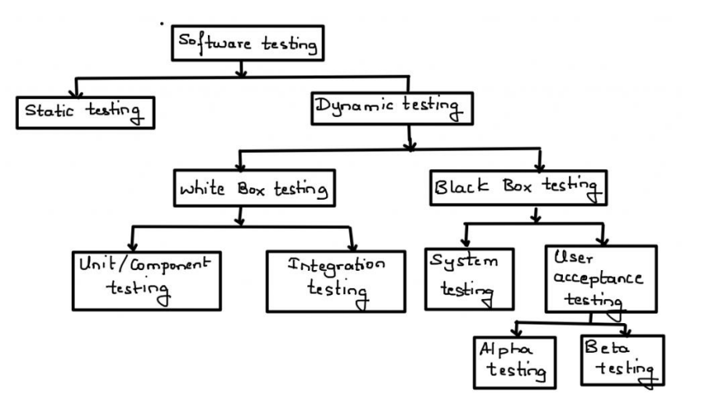

Static Testing Techniques

Static testing techniques involve evaluating software artifacts (such as requirements, design documents, and code) without executing the code. These techniques help identify defects early in the software development lifecycle, improving quality and reducing costs. Here are the main types of static testing techniques:

1. Reviews

* Informal Reviews: Unstructured reviews, usually a quick check by peers or stackholders.
* Walkthroughs: A team-oriented process where the author explains the document or code to the group for feedback.
* Technical Reviews: A structured review lead by a moderator to evaluate technical aspects of the software artifact.
* Inspections: A highly formalized and detailed process to detect defects, adhering to defined procedures.

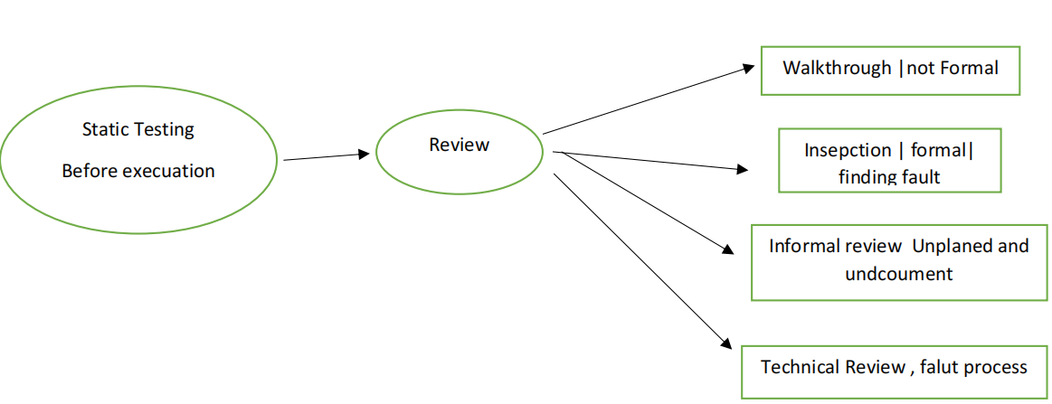

Dynamic Testing Techniques

The process of evaluating a system or component based upon its behaviour during execution.

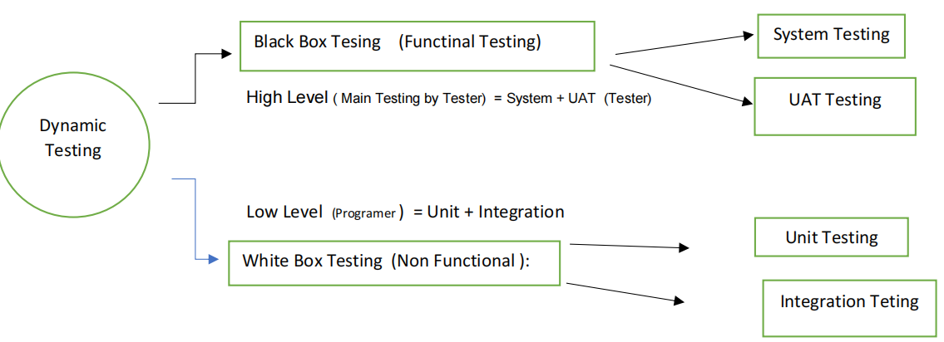

Levels of Testing

1. Unit Testing: Tests individual units of code, such as classes, functions, and methods, to ensure they work as expected and meet requirements.
2. Integration Testing: Tests that combined units of code work well together.

* Top-down
* Bottum-up
* Sandwich
* Big-Bang

To check modules are communicating each other as DFD Data Flow Diagram

which is specified in TDD (Technical Document Diagram)

1. System Testing: Tests the entire software system, including its performance, security, and user flows.
2. Acceptance Testing: Validates the product against the requirements of the end user.

Alpha Testing: done by tester in company in presence of customer

Beta Testing: done by customer to check software is ok, satisfy requirement

Testing Types:

Functional Testing:

* For testing the software or application functionality end to end process is called functional testing.
* There are different types of points:
* Verification of the requirement specification in the software application.
* After analysis, the requirement test-plans.
* After planning the tests, the tester will be written the test case.
* After written the test case, tester will make a document of the traceability matrix.
* The tester will execute the test case.

Non-Functional Testing:

* Non-functional testing is a type of software testing that evaluates a product’s

Non-functional attributes, such as performance, usability, and security.

* Load testing
* Reliability
* The readiness of a system
* Usability testing

White Box testing: (with code) low level

* It was conducts on internal logic of the programs.
* Programming skills are required.
* It is followed by developers.
* Monitoring internal structure, check internal logic, done by developer.
* It includes unit testing and integration testing.

Black Box Testing: (without code) High level

* It was conducts on functionality of application whether it was working according to customer requirement or not.
* This testing is followed by testers.
* The testing is done without the internal knowledge of the products.
* It includes system testing and user acceptance testing.

Smoke testing:

* Smoke testing is also known as build verification testing.
* It is first testing on newly released build … (Build Verification Testing)
* (Testing on newly released build →compulsary requirement )
* Check → the deployed software build is stable or not.
* It is part of basic testing.

Sanity testing:

* Sanity testing is performed by Testers alone.
* Sanity testing, build is relatively stable.
* It is done by stable buildings.
* It is a part of regression testing.

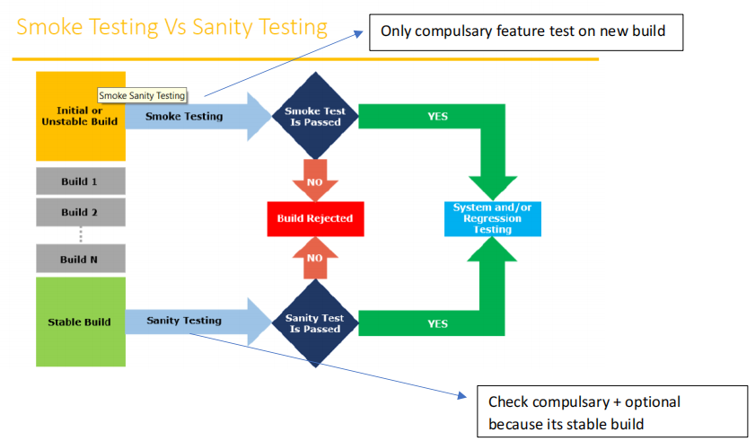

Static Testing:

* Static testing done without execution of code of software application to check defect in it.
* Developer check the own code under this Static testing.

Static Techniques has 3 types:

1.Review: